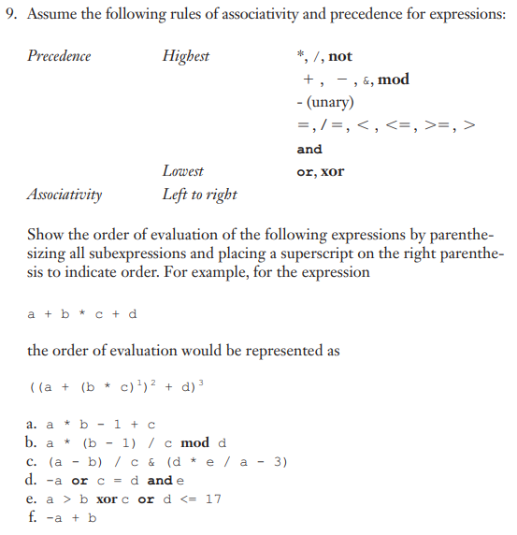

**9.**

1. **(((a * b)1 – 1)2 + c)3**
2. **(((a * (b – 1)1)2 /c)3 mod d)4**
3. **(((a – b)1 /c)5 & (((d * e)2 /a)3 – 3)4)6**
4. **((-a)1 or ((c = d)2 and e)3)4**
5. **(((a > b)1 xor c)3 or (d <= 17)2)4**
6. **(-(a + b)1)2**

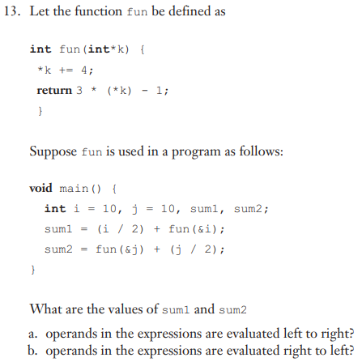

**13.**

1. **sum1 = 46, sum2 = 48**
2. **sum1 = 48, sum2 = 46**

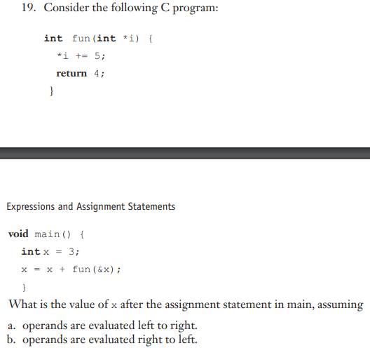

**19.**

1. **x = 7**
2. **x = 12**